NEDC Dancewear

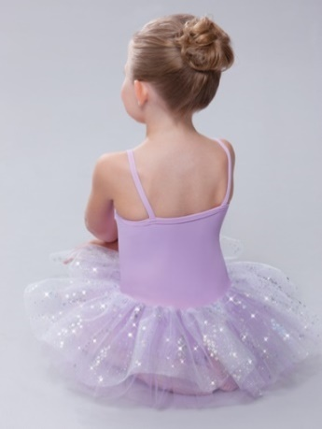
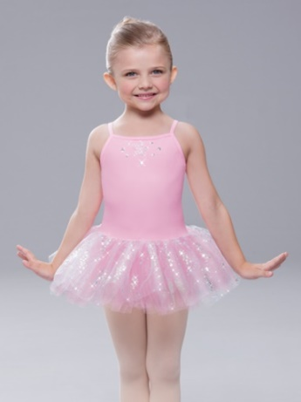
NEW ~ Sparkle Tutu Leotard $22.00 Group Order or In Stock
Add $7.50 S&H on Individual Orders
Pink or Lilac
IN STOCK PRICE: Ask if item is in stock
INDIVIDUAL ORDER: Place an order ANY time & Include S&H in cost or get a friend to order with you & share S&H cost

GROUP ORDERS: Order & Pay by:
NOVEMBER 1
FEBRUARY 1

Camisole Leotards OR
Short Sleeve Scoop Neck Leotards

$15.00 Group Order or In Stock
Add $7.50 S&H on Individual Orders
Camisole: Black, White, Carnation Pink, Red, Turquoise
Dance Shorts
Black
$15.00 – Group Order
Short Sleeve: Light Blue, Lilac, Navy, Forest Green, Maroon, Pink, Black

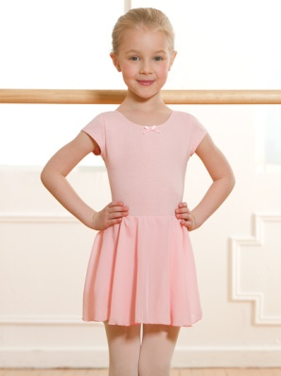
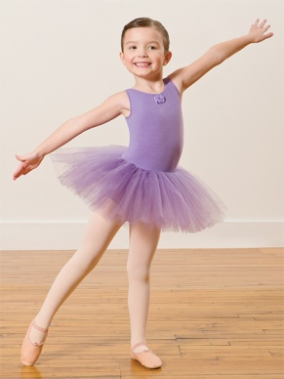
Princess Tutu or Skirted Leotard: Pink, Lilac or Light Blue
$20.00 Group Order or In Stock
TIGHTS
Add $7.50 on Individual Orders . .
Dance Bags
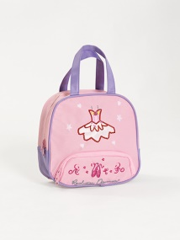
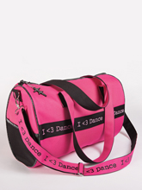
. Suntan Convertible Non-Competition Tights: $8.00
Pink Convertible Ballet Tights: $8.00
Black Convertible/Full Footed Tights: $8.00
Competition Capezio Tights Stirrup $16.00/ Convertible: $15.00
$12.00
$15.00

