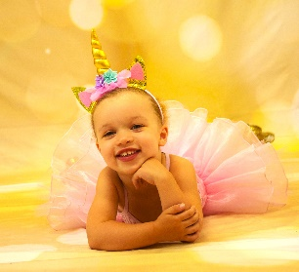

**New England Dance Center**

**1141 Main St Worcester**

**508-963-6312**

**THURSDAY**

4:00-5:00 TAP LIGHTNING

5:00-5:45 JAZZ LIGHTNING

5:00-6:30 TAP & JAZZ MINIS

5:45-6:30 TECHNIQUE STORM

6:30-7:30 PRODUCTION STORM

7:30-8:30 TAP THUNDER

**MONDAY**

4:45-5:45 TAP & BALLET (4-8)

4:45-5:45 TAP & JAZZ (8+)

5:45-6:45 BROADWAY BABIES (1.5-4)

5:45-6:45 FUNK N’ JUMP (4-10)

6:45-7:45 BALLET (ages 8+)

6:45-7:45 FUNK N’ JUMP (8+)

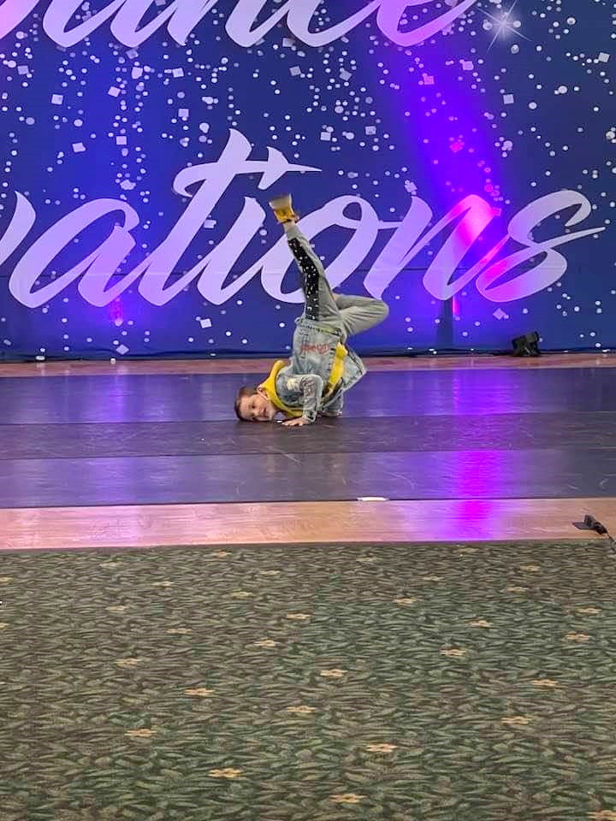

**TUESDAY**

4:00-5:00 TAP ELITE

5:00-5:45 ACRO ELITE

5:00-5:45 BALLET INTENSIVE

5:45-6:30 ACRO INTENSIVE

5:45-6:30 BALLET ELITE

6:30-7:30 LYRIC INTENSIVE

6:30-7:30 INTRO TO HIP HOP (5-10)

7:30-8:30 TAP & JAZZ FUNK (7-13)

7:30-8:30 LYRIC ELITE

**2022-23 SCHEDULE**

**WEDNESDAY**

4:00-4:30 CONDITIONING INTENSIVE

4:00-4:30 HIP HOP ELITE

4:30-5:30 TAP INTENSIVE

5:30-6:30 HIP HOP INTENSIVE

5:30-6:30 FUNK, RHYTHM, & JUMP (5-10)

6:30-7:30 PRODUCTION INTENSIVE

7:30-8:30 JAZZ ELITE

CLASSES IN RED are

Recreational/Non-Competitive OPEN to ALL STUDENTS

**FRIDAY**

4:00-4:45 HIP HOP LIGHTNING

4:45-5:30 LYRIC LIGHTNING

5:30-6:15 BALLET THUNDER

5:30-6:15 ACRO LIGHTNING

6:15-7:00 BALLET LIGHTNING

6:15-7:00 ACRO THUNDER

7:00-8:00 HIP HOP THUNDER

**www.newenglanddancecenter.com**